Here is a simplified walk-through on the procedure to play RealBridge.
- First, you will have access to a website link to the Session/Game. This will come to you as an eMail (Figure 1), or as a line on the website (Figure 2). It is recommended that you first test your camera & mic – at least before your first time.
Hi, All,
CAMERA/Mic test link:
https://play.realbridge.online/camera.html
Session Monday 12/4/21:
https://play.realbridge.online/ct.html?p=210412122473&q=PlayJGOBRB005
Look forward to seeing you all there. Can you let me kow if you'll
be playing?

Figure 1
Figure 2

- When you click on the Next Session (12/4/21 @ 10am for 10:30 link, you will be brought to Figure 3.
Please note that the session will usually not open before the stated start time, and in that case you will get a “Session Not Started by Director” message. You simply repeat the click on the link to try again.
When you join the James O’ Brien RB ‘Club’, you will be asked for your CBAI NBID number (or the old CBAI registration number, if you don’t have it), your “Home” club and. and your Grade. After registration, you will get a confirmation, and a PIN code. You can use any of these three codes as the ID number in Fig. 3. Also, please try to be as accurate as you can when entering your name.
When all details are entered, click Login
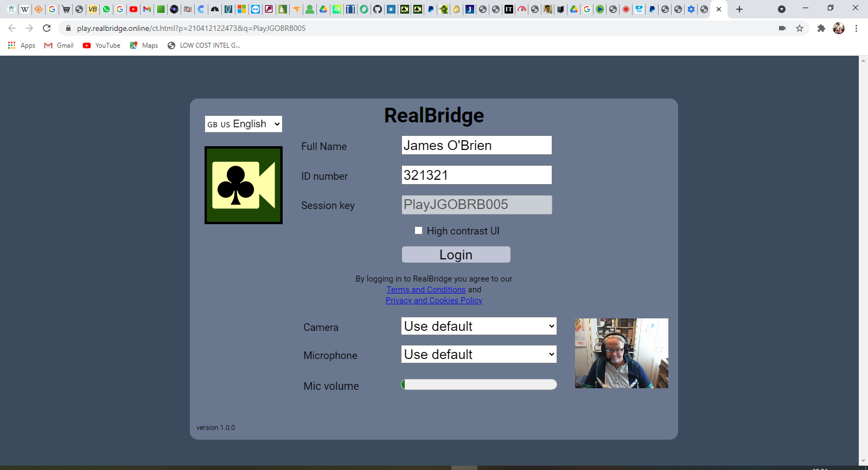
Figure 3

- When you’ve clicked Login, you will be brought to the ’Room’, as in Figure 4.
There is a Lobby area, where you will first appear. To join a Table, you simply click on the relevant Table and position (NSEW). You will then appear – as in Figure 5. You will be on the screen where “Andy Bowles” is in Fig. 5
(Due to GDPR regulations, we have to use the graphics supplied by RealBridge as part of their Player Guide)
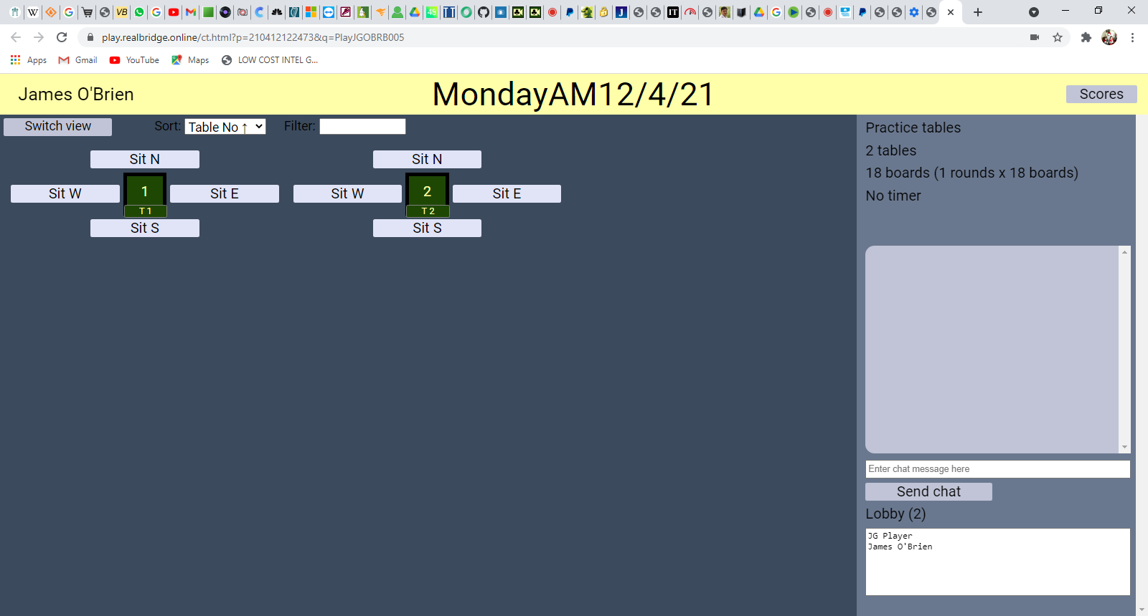Figure 4
Figure 5
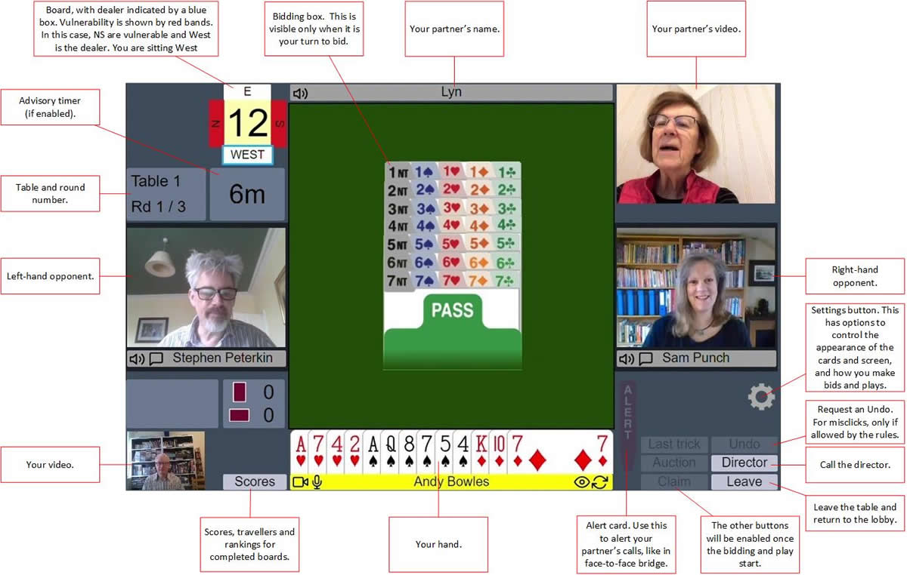
Figure 5

